**Search and rescue helicopter statistics: data tables**

**(SARH - Search and Rescue Aviation programme)**

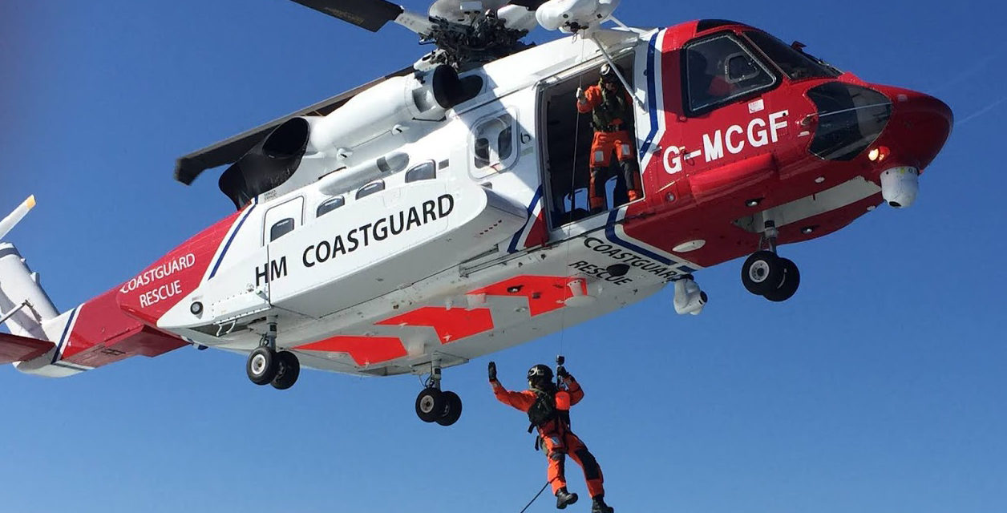

From: [**Department for Transport**](https://www.gov.uk/government/organisations/department-for-transport) and [**Maritime and Coastguard Agency**](https://www.gov.uk/government/organisations/maritime-and-coastguard-agency)

Published: 18 November 2015

Last updated: 20 June 2023

Link to dataset: <https://www.gov.uk/government/statistical-data-sets/search-and-rescue-helicopter-sarh01>

**1. DATA SOURCE**

Data on civilian search and rescue helicopter activity in the United Kingdom, produced by **Department for Transport**.

This release covers civilian search and rescue helicopter (SARH) operations in the UK. The data originates from the Aeronautical Rescue Co-ordination Centre (ARCC) who are responsible for the co-ordination of search and rescue (SAR) helicopters, and is provided to the Department for Transport (DfT) by the Maritime and Coastguard Agency (MCA).

**DATA CONTENTS**

Statistics on civilian search and rescue helicopter (SARH) taskings for the UK, with breakdowns by tasking type, location type (land, maritime or coast) and helicopter base, throughout the April 2015 to March 2023 period. The data are derived from information recorded by the Aeronautical Rescue Coordination Centre (ARCC), who are responsible for the coordination of search and rescue helicopters.

**DATA COLLECTION**

The Search and Rescue Helicopter (SARH) statistics uses data originating from the Aeronautical Rescue Coordination Centre (ARCC). ARCC are responsible for the co-ordination of the search and rescue helicopters, from answering the initial request through to the conclusion of the tasking. Previously, data was derived from the helicopter operators recording system, and provided to DfT by the Maritime and Coastguard Agency (MCA).

**Variables**

Following a tasking, the ARCC records incident data which gets validated and verified by the MCA and DfT on a regular basis and signed off at the end of each month.

Variables in the current data source include:

* tasking count
* tasking category
* tasking location
* location type

**1. Tasking count**

A tasking is defined as the response of a UK SARH helicopter to an emergency as notified by the ARCC. If an emergency occurs where a helicopter is called out more than once, this is usually counted as one tasking. If helicopters from different bases are called out to the same emergency, this is counted separately - once for each base.

This means that the definition of “taskings” is slightly different to the definitions of “callouts” and “incidents” used by the Ministry of Defence. The statistics also include those taskings which have been stood down before lift-off. This is due to a lot of activity taking place prior to the actual lift-off whereby time and resources are being used.

Currently, the ARCC data can be compared to the old data source used by the helicopter operators to validate the number of SARH taskings every month. Therefore, the number of taskings is believed to be accurately recorded.

**2. Tasking category**

The tasking category (rescue or recovery, pre-arranged transfer, search only and support) is derived from a free text field completed by the ARCC and coded by database administrators at the MCA using the description of the tasking. In addition, the tasking narrative derives information which the DfT use to cross check information received by the ARCC.

Tasking narrative example:

Tasked by UK SAR Helicopter of a rescue of a male who had fallen down some stairs on-board a cruise liner in Plymouth. Communications established with vessel who advised that incident involved 2 casualties. Winchman Paramedic and equipment lowered rescued to vessel. First casualty recovered to aircraft with winchman before returning and recovering second casualty in stretcher and returning back to Plymouth for medical care.

In this example, the Tasking Category would be coded as a rescue or recovery. The Location Type would be coded as a (leisure) vessel tasking. The Number of People Rescued would be coded as 2 persons rescued. The Tasking Outcome would be coded as a completed tasking.

**3. & 4. Tasking location and location type**

If a rescue or recovery takes place then the location is recorded based on the coordinates of where the persons were found. If a pre-arranged transfer occurs, some operators may record the midpoint of the tasking in the database, which could mean the tasking will have been recorded to take place over maritime when in fact, should be classed as coast or land. There are checks in place to make sure all taskings involving pre-arranged transfers are consistent and uses the final location of the tasking. For other tasking types, the initial location (for example, where a search will take place) is recorded, as supplied by the tasking authority such as the police force. It is not possible to assess whether the original coordinates provided to the tasking authority for a search were accurate.

The coordinates of the tasking location are also used to define the location type (land, coast and maritime). The latitude and longitude of the tasking location are overlaid onto a map of the UK, and distances between the taskings and the outline of the map are used to categorise the data.

The definitions of the boundaries between land, coast and maritime were chosen based on other widely used definitions, what was sensible given the nature of the topic and what was possible using the data. This breakdown is only as accurate as the coordinate data. If latitude or longitude are recorded inaccurately then this may also impact upon the location, although the risk of such inaccuracies is perceived as low.

The location type of a tasking (meaning whether the tasking took place, for example, on a beach/cliff, mountain, or vessel) is based on the tasking narrative and standard definitions used by the ARCC. This gets validated by the DfT whereby the co-ordinates of each tasking are overlaid onto a map of the UK to ensure the location type is recorded as accurately as possible (for example, we would expect most beach/cliff rescues to take place around coastal/land areas of the UK).

**DATA Confidentiality**

The published statistics does not reveal any private information about any individual or organisation and confidential information will be kept securely where access to data is controlled in accordance to departmental policy.

“Search and Rescue Helicopter Statistics: Notes and Definitions.” *GOV.UK*, www.gov.uk/government/statistics/search-and-rescue-helicopter-annual-statistics-year-ending-march-2023/search-and-rescue-helicopter-statistics-notes-and-definitions--2. Accessed 27 June 2023.

**An explanation for why I’ve chosen this data set.**

I’ve chosen this data set as I find it very interesting and admirable. I think we take for granted emergency services, and mostly they are not recognized and honoured as they should. While we sleep peacefully every night, man and women in rescue teams work hard and lose their lives every day and night. I would like to show, at least a little token of an appreciation, and gratitude for everything they do, by analysing data on civilian search and rescue helicopter activity to be able to present and better understand their hard work and everyday sacrifice.

**2. DATA PROFILE**

**1. CLEAN THE DATA**

The data ‘sarh0112’ has 19238 rows and 11 columns.

While conducting data wrangling I have found in sarh0112, with Python, 20 duplicates. I have rechecked them in Excel and decided to create a new dataframe that doesn’t include duplicates, df_sarh0112_nodups.

After the Data Quality check the dataset contains 19218 rows and 11 columns.

A few corrections were made in Python and Excel regrading column names: for better understanding “Base” was renamed to “Name_of_the_Base”, while all other corrections regarding column name was made due to Python’s way of writing names.

Python – “Base” was renamed to “Name_of_the_Base”

“Day of week” was renamed to “Day_of_week”

“Type of tasking” to “Type_of_tasking”

“ Tasking location” to “Tasking_location”

“Tasking outcome” to “Tasking_outcome”

“Time of day” to “Time_of_day”

Excel – “Duration” was renamed to “Tasking_duration” – I decided to rename this column to be consistent with other.

**2. UNDERSTAND THE DATA**



Please have a look at Excel file sarh0112_cleaneddata.





**3. LIMITATIONS AND ETHICS**

Tabulations and basic checks are also performed on the SARH data to make sure they are in line with expectation (for example, we would expect SARH taskings to peak in the summer months in a given year due to greater leisure activity). The data are also checked with previous years, looking for any unexpected changes for each variable. Where uncertainties exist in data outputs, these are highlighted in the statistical releases.

The information used to compile these statistics provides details on individual events (for example, a brief description of the circumstances of an incident, including details such as the age and gender of those involved), though sensitive personal or identifiable personal data is not sent to DfT. The published statistics do not therefore reveal any private information about any individual or organisation.

DfT aims to publish as much data as is possible whilst ensuring that confidentiality is maintained.

There exist additional data sets that I would like to use as well:

**Taskings by base, type and the number of rescued and assisted**

**SARH0101** Month by base

**SARH0102** Tasking by base and outcome by tasking type

**SARH 0113** Rescued and assisted by base

**Taskings by location and region**

**SARH 0114** Breakdown of location by base

Going through the data only “limit” I could find is that there is no data about what happened to the rescued people after. Did rescue person survived the rescue or at the end succumb to injuries?

In these additional data there is a lot of missing values for Portland Base due to its closure on June 2017.

**3. QUESTIONS TO EXPLORE**

Which is the busiest tasking day in the year and which the least busy?

What Base is the busiest in the year, which one is the least busy? Possibly why?

Type of taskings by region?

What region has the biggest number ‘of Search only’ tasking? Possibly why? (In a area where I live exists Psychiatric hospital, and very often search and rescue helicopter looks for a missing patient.)

Does seasonality exists? My hypothesis is that during the summer it should be expected biggest number of taskings due to tourists attraction, increased number of people.

What is the average number of taskings per day?

What is the average number of taskings per region?

What is average duration time of taskings per base?